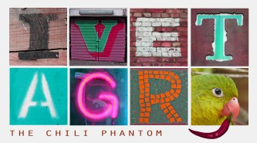
Chili Parrot Interview
(Chili papagáj interjú)

Agents. Here are the answers the chili parrot gave to all your questions. It looks like nonsense.
(Ügynökök! Itt vannak a válaszok, melyeket a chili papagáj adott a kérdéseitekre. Badarságnak tűnik.)

- What did you do last week? – I sang a song and then I went to the beach.
- Who did you meet yesterday? I chose a book from the library and took photos.
- Which hotel did you stay in last week? I wrote a book and then went sightseeing.
- How did you travel to Amsterdam? I stayed with friends and rented a car.
- Where did you go for lunch yesterday? I went by car and saw a park.
- Why did you come to the palace? I went for a run and booked a room.
- When did you arrive in Amsterdam? I ate breakfast and then went on a tour.
- What did you eat for dinner last night? I thought all evening and made a poster.

Exercise 1 – Looking at the answers given by the parrot, write the past simple of the following verbs:
(1. feladat: Nézd meg a papagáj által adott válaszokat, és írd le a következő igék egyszerű múlt alakját)

sing >
go >
choose >
take >
write >
stay >
rent >
see >
book >
eat >
think >
make >

