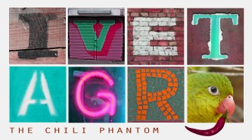
Chili Parrot Report
(Chili papagáj jelentés)

“Hi Agents. Have a look at the map at http://g.co/maps/j64et and fill in the gaps with the missing information. When you are finished, the colored letters will spell out another name for the chili parrot. Get to work!”
(Üdv Ügynökök! Nézzétek meg ezt a térképet: http://g.co/maps/j64et , és töltsétek ki az üresen hagyott részeket a hiányzó információkkal. Ha befejeztétek, a színes betűk kiadják a chili papagáj másik nevét. Lássatok munkához!)

Brazil
There are only a few chili parrots left in the . People have killed them for their golden feathers. In Brazil, there are still some chili parrots in the area of the
Mexico
There are some chili parrots left in the South of Mexico. They like chili peppers and this gave them their name. In Mexico, the chili parrots are because of the many chili peppers. If the pepper is really ,the parrots like them more.
Costa Rica
In the of 2011 in Costa Rica, police arrested two men who tried to transport twenty chili parrots on a to Europe. The chili parrots were released into a Costa Rican National Park.
Cuba
The first chili parrot was discovered by Alexander von Humboldt in 1801. He named the parrot when he saw it was eating chili peppers.

Mozambique
years ago, Mozambique was the country with the largest chili parrot population. , it is very difficult to see chili parrots in the wild.
South Africa
In South Africa, the chili parrots symbolize eternal youth. They are seen as sacred
.
Papua New Guinea
Over the past years, chili parrots all over the world have nearly all disappeared. In Papua New Guinea, more than two chili parrots have disappeared in the last six months.
Thailand
The chili parrots are famous for their feathers which contain . In Thailand, there was a market for the golden chili parrot feathers until the chili parrot feather business collapsed in the year 2002.

The chili parrot is also called:
(A chili papagájt úgy is hívják, hogy:)

