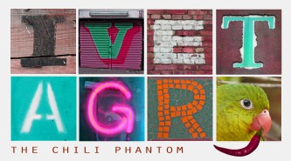

WHAT DO YOU HAVE?... WHAT ARE YOU LIKE?

Match the adjectives in A with their opposites in B.
(Párosítsd a mellékneveket (A) az ellentétpárjukkal (B))

A | B
clean

big

thin

beautiful | expensive ugly young  happy long exciting  fat dirty small cold  unfriendly bad
warm

sad

friendly

cheap

boring

short

old

good

Make questions for each of the items and adjectives below.
(Kérdezz rá minden egyes lenti tárgyra és melléknévre.)

1 | 2 | 3
expensive | small | You  friendly

EX) Do you have an expensive laptop?
Do you have a small mobile phone?
Are you friendly?

