

Suspect Information Texts

You will need to write a text about each of the suspects. Use the following example to help you write each text.
(Kell írnod egy szöveget a gyanúsítottakról. Használd segítségként a követező példát a szövegek megírásakor.)

Example: „This is ... His / her address is... His / her telephone number is ... We don’t know his / her email yet. He / She works as a ... He / She is married / single. He / She is ... years old. He / She is from ... He / She is ... His / her hair is long / short and curly / straight and (colour). He / She has (colour) eyes. He / she is tall / short and big / thin. He / she has a big / small nose / freckles / glasses / eyebrows / mouth / lips / teeth. His / her attribute is...“

Here is an example with “Suspect 1”:
(Itt van egy példa az „1. gyanúsítottal”.)

Suspect 1

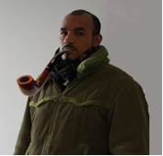

This is John Barber. His address is 78 Lavender Gardens, Bettersea, London, SW11 1DJ. His telephone number is 0044 20 6792 5443. We don’t know his email yet. We don’t know what he does. He is single. He is 33 years old. He is from England. He is English. His hair is short, straight, and black. He has brown eyes. He is tall. He has a big nose and eyebrows. He is known for his pipe.

Now write your own texts of the other nine suspects.
(Most írd meg a saját szövegeidet a többi kilenc gyanúsítottról.)

.

Suspect 2



Suspect 3

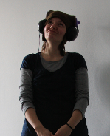

Suspect 4


Suspect 5


Suspect 6



Suspect 7



Suspect 8


Suspect 9


Suspect 10
