

Missing Information!

A1 B1 A2 B2 A3

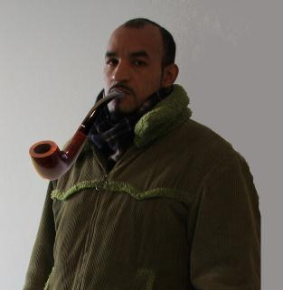

B3 A4 B4 A5 B5
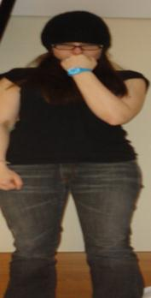
?

Name: Barber, John
Address: 78 Lavender Gardens, Battersea, London, SW11 1DJ
Telephone number: 0044 20 6792 5443
Email:
Job:
Family status: Single
Age: 33
Country of origin: England
Nationality: English
Hair: Black, Short
Eyes: Brown
Special characteristic: Pipe

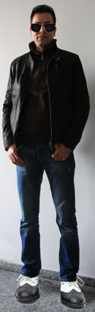
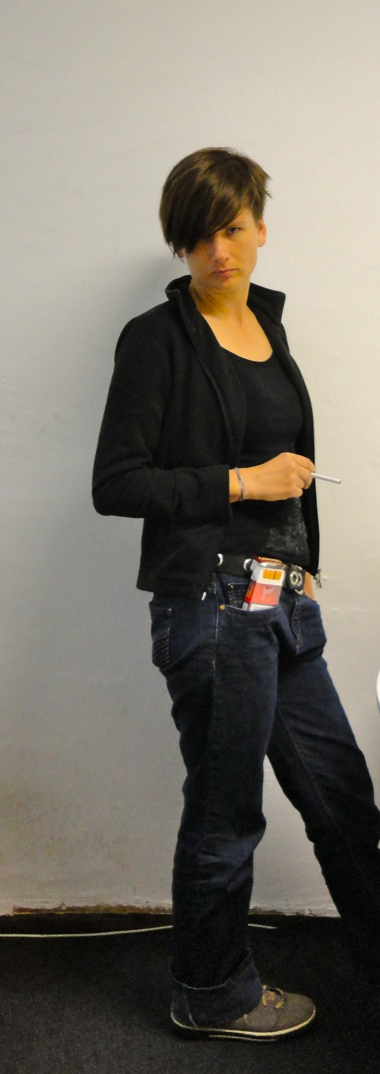
?
?
?
?

Suspect B1 is John Barber. His address is 78 Lavender Gardens, Bettersea, London, SW11 1DJ. His telephone number is 0044 20 6792 5443. We don’t know his email yet. We don’t know what he does. He is single. He is 33 years old. He is from England. He is English. His hair is short, straight, and black. He has brown eyes. He is tall. He has a big nose and eyebrows. He is known for his pipe.

Ask your partner (A) questions about the suspects with the missing photo. He or she has to give the right answers. Fill in the missing information in the table below. After that your partner will ask you about the other suspects.

(Kérdezd a partneredet (A) a gyanúsítottakról, akiknek nincsen képük. A partnerednek be kell jelölnie a jó választ. Írd be a hiányzó információkat a lenti a táblázatba! Utána a partnered kérdez majd Téged a többi gyanúsítottról.)

Example (Itt találsz egy példát):

This is how you can ask (Így tudsz kérdezni):

Tell me something about suspect number... (Mondj valamit nekem a(z)… számú gyanúsítottról!...)

What is her / his address? (Mi a címe?)
What is her / his telephone number? (Mi a telefonszáma?)
What is her / his email? (Mi az email címe?)
What does he/ she do? (Mivel foglalkozik?)
How old is she / he? (Hány éves?)
Where is she / he from? (Honnan származik?)
What is her / his nationality? ( Milyen nemzetiségű?)
What kind of hair does he/she have? (Milyen a haja?)
What colour are his/ her eyes? (Milyen a szeme?)
Is she / he tall or short, big or thin? (Magas, alacsony, nagydarab vagy vékony?)
What are his or her special characteristics? (Van valamilyen különleges ismertetőjele?)

What is he/she known for? (Milyen jellegzetes ismertetőjegye van?)

This is how you can answer (Így tudsz válaszolni):

We don’t know her / his address yet. Or: Her / his address is... (Még nem tudjuk a címét. VAGY: A címe ... )
Her / his telephone number is... (A telefonszáma…)
We don’t know her / his email. Or: Her / his email is... (Nem tudjuk az email címét. VAGY: Az email címe …)
She / he is a... (Ő …-ként dolgozik.) Or: We don’t know what he/she does.
She / he is ... years old. (Ő … éves.) Or: We don’t know how old he/she is.
She / he comes from ... (Ő … (-ból) származik.)
She / he is ... (Ő … (nemzetiség).
Her / his hair is ... (A haja…) Or: We don’t know what kind of hair he/she has.
Her / his eyes are ... (A szeme…) Or: We don’t know what his/her eyes are like.
She / he is (tall/short) and (big/thin). (Ő … (pl.: magas) és … (pl.: vékony).)
He / She has freckles, a big / small nose, glasses, big eyebrows.... (Ő (neki van)…)
He / she is known for his/her ...( Az ő ismertetőjegye…)
 | A.1 | A.2 | A.3 | A.4 | A.5

Name
Address
Number
Email
Job
Age
Country
Nationality
Hair
Eyes
Other
Known for

