

Missing Information!

A1 B1 A2 B2 A3

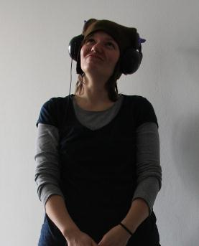 ? ? 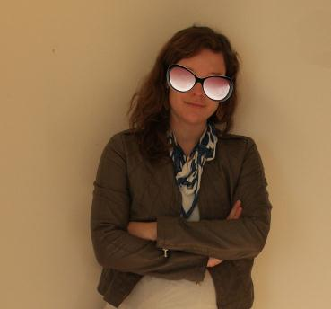


B3 A4 B4 A5 B5

? ? ?

Name: Johansen, Rasmus
Address: Tietgensgade 37, DK-1566, Copenhagen V, Denmark
Telephone number: 0045 45678001
Email: RJ-Smooth-Operator@musiclovers.com
Job: Nurse
Family status: Single
Age: 31
Country of origin: Denmark
Nationality: Danish
Hair: Brown, Straight
Eyes: Blue


Special characteristic: Headphones

Suspect A1 is Rasmus Johansen. Her address is Tietgensgade 37, DK-1566, Copenhagen V, Denmark. Her telephone number is 0045 45678001. Her email address is RJ-Smooth-Operator@musiclovers.com. She is a nurse. She is single. She is 31 years old. She is from Denmark. She is Danish. Her hair is short, straight, and brown. She has blue eyes. She is short. She is known for her headphones.

Ask your partner (B) questions about the suspects with the missing photo. He or she has to give the right answers. Fill in the missing information in the table below. After that your partner will ask you about the other suspects.

(Kérdezd a partneredet (B) a gyanúsítottakról, akiknek nincsen képük. A partnerednek be kell jelölnie a jó választ. Írd be a hiányzó információkat a lenti a táblázatba! Utána a partnered kérdez majd Téged a többi gyanúsítottról.)

Example (Itt találsz egy példát):

This is how you can ask (Így tudsz kérdezni):

Tell me something about suspect number... (Mondj valamit nekem a(z)… számú gyanúsítottról!...)

What is her / his address? (Mi a címe?)
What is her / his telephone number? (Mi a telefonszáma?)
What is her / his email? (Mi az email címe?)
What does he/ she do? (Mivel foglalkozik?)
How old is she / he? (Hány éves?)
Where is she / he from? (Honnan származik?)
What is her / his nationality? ( Milyen nemzetiségű?)
What kind of hair does he/she have? (Milyen a haja?)
What colour are his/ her eyes? (Milyen a szeme?)
Is she / he tall or short, big or thin? (Magas, alacsony, nagydarab vagy vékony?)
What are his or her special characteristics? (Van valamilyen különleges ismertetőjele?)
What is he/she known for? (Milyen jellegzetes ismertetőjegye van?)

This is how you can answer (Így tudsz válaszolni):

We don’t know her / his address yet. Or: Her / his address is... (Még nem tudjuk a címét. VAGY: A címe ... )
Her / his telephone number is... (A telefonszáma…)
We don’t know her / his email. Or: Her / his email is... (Nem tudjuk az email címét. VAGY: Az email címe …)
She / he is a... (Ő …-ként dolgozik.) Or: We don’t know what he/she does.
She / he is ... years old. (Ő … éves.) Or: We don’t know how old he/she is.
She / he comes from ... (Ő … (-ból) származik.)
She / he is ... (Ő … (nemzetiség).
Her / his hair is ... (A haja…) Or: We don’t know what kind of hair he/she has.
Her / his eyes are ... (A szeme…) Or: We don’t know what his/her eyes are like.
She / he is (tall/short) and (big/thin). (Ő … (pl.: magas) és … (pl.: vékony).)
He / She has freckles, a big / small nose, glasses, big eyebrows.... (Ő (neki van)…)
He / she is known for his/her ...( Az ő ismertetőjegye…)
 | B.1 | B.2 | B.3 | B.4 | B.5

Name
Address
Number
Email
Job
Age
Country
Nationality
Hair
Eyes
Other
Known for

