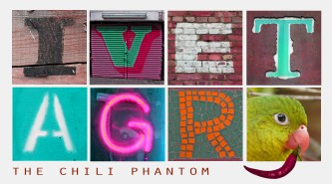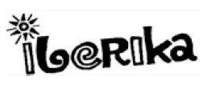

The Lisbon Castle Café

Opening Hours:

Monday to Friday 9:00 AM - 7:00PM

Saturday 11:00 AM - 6:00 PM
Sunday Closed

 | Coffee and Hot Drinks
Coffee small |  | 1.50
Coffee large |  | _____
Tea |  | 1.75
Espresso |  | 1.00
Hot Chocolate |  | 3.50
 | Snacks and Light Bites
Sandwich with Chesse |  | 3.00
Sandwich with Ham |  | 3.00
Bagel with Egg |  | _____
Pretzel |  | _____
 | Desserts and Pastry
2 Brownies |  | 1.50
2 Cookies |  | _____
Croissant |  | 1.25

