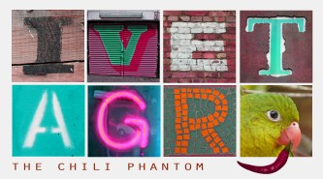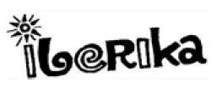

The Lisbon Castle Café

Opening Hours:

Monday to Friday 9:00 AM - 7:00PM

Saturday 11:00 AM - 6:00 PM
Sunday Closed

 | Coffee and Hot Drinks
Coffee small |  | 1,50
Coffee large |  | 2.50
Tea |  | _____
Espresso |  | 1.00
Hot Chocolate |  | 3.50
 | Snacks and Light Bites
Sandwich with Chesse |  | _____
Sandwich with Ham |  | _____
Bagel with Egg |  | 4.50
Pretzel |  | 2.00
 | Desserts and Pastry
2 Brownies |  | _____
2 Cookies |  | 2.00
Croissant |  | 1.25

