 | 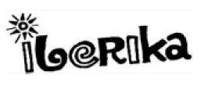

Personal Pronouns and Possessive Adjectives
Személyes és birtokos névmások

Complete this worksheet and email it to your English teacher.
Egészítsd ki ezt a feladatlapot és küldd el az angoltanárodnak!

Match the possessive adjectives to the personal pronouns:
(Párosítsd a birtokos névmásokat a személyes névmásokhoz)

your |  |  |  |  | it’s
 |  |  |  | our
 |  |  | their
 |  | his
 | her |  |  |  |  | my *

I | you | he | she | it | we | they

*your (a te …-d; a ti …-tek, tok), it’s (az ő…-je, annak a …-a,-e,-ja,-je /semlegesnem/),
our (a mi …-unk, -ünk), their (az ő…-uk, -ük), his (az ő…-je /hímnem/),
her (az ő…-je /nőnem/), my (az én…-m /valamim, valakim/)

What is his name? | 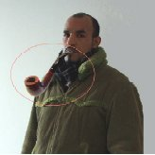
His name is John “Mr.Spock” Barber.

What is he known for?

He is known for his pipe.

What is her name? | 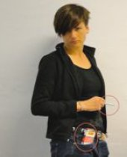
Her name is Liga “Smokey” Kovals

What is she known for?

She is known for her cigarettes

