 | 

Suspect Information
Gyanúsított információ

Ask the other agents questions to find out about all ten of the most wanted suspects.
(Tegyél fel kérdéseket a többi ügynöknek, hogy megtudd, hogy ki a tíz legkeresettebb gyanúsított!)

Suspect 1 |  | 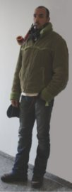
First Name: | John
Last Name: | Barber
Alias: | Mr. Spok
Country: | England
Nationality: | English

Suspect 2 |  | 
First Name: | Liga
Last Name: | Kovals
Alias: | Smokey
Country: | Latvia
Nationality: | Latvian

Suspect 3 |  | 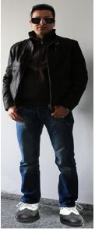
First Name:

Last Name:

Alias:

Country:

Nationality:

Suspect 4 |  | 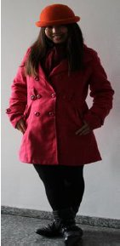
First Name:

Last Name:

Alias:

Country:

Nationality:

Suspect 5 |  | 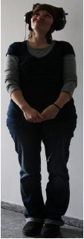
First Name:

Last Name:

Alias:

Country:

Nationality:

Suspect 6 |  | 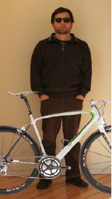
First Name:

Last Name:

Alias:

Country:

Nationality:

Suspect 7 |  | 
First Name:

Last Name:

Alias:

Country:

Nationality:

Suspect 8 |  | 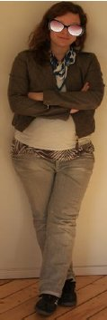
First Name:

Last Name:

Alias:

Country:

Nationality:

Suspect 9 |  | 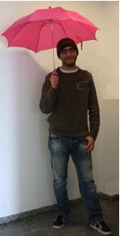
First Name:

Last Name:

Alias:

Country:

Nationality:

Suspect 10 |  | 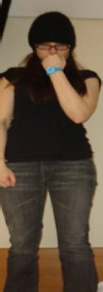
First Name:

Last Name:

Alias:

Country:

Nationality:

